# TFS Working On - Version 1.1

TFS Working On is a simple system tray utility that makes it easier to record your time spent on TFS Work Items.

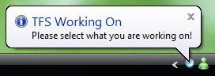

Simply specify your server and project, then search for your Work Item and you are tracking your time.

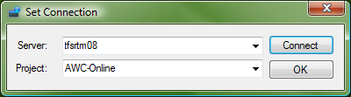

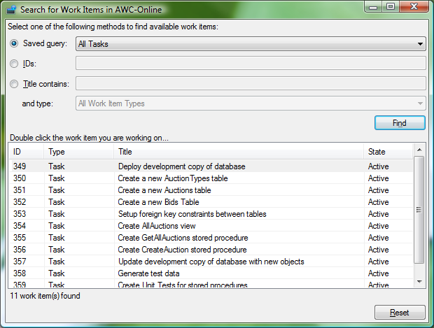

The icon turns **green** to notify you that you are tracking your time.

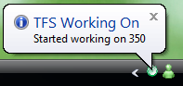

This will record your time in the history of the work item whenever you stop working on the item. To stop working on, double click the icon or select stop from the menu, and the work item is updated and the icon turns **red**.

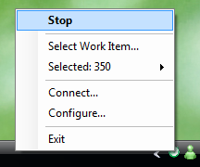

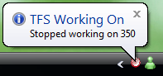

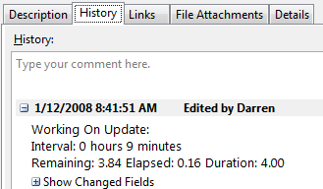

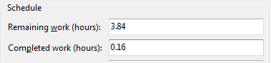

You can also specify your estimates against a work item so that you can record how you are going.

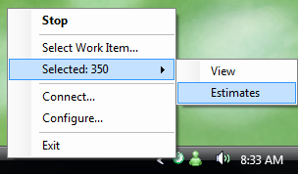

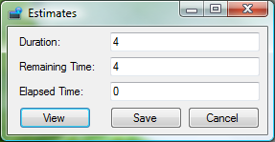

Access to the work item is available.

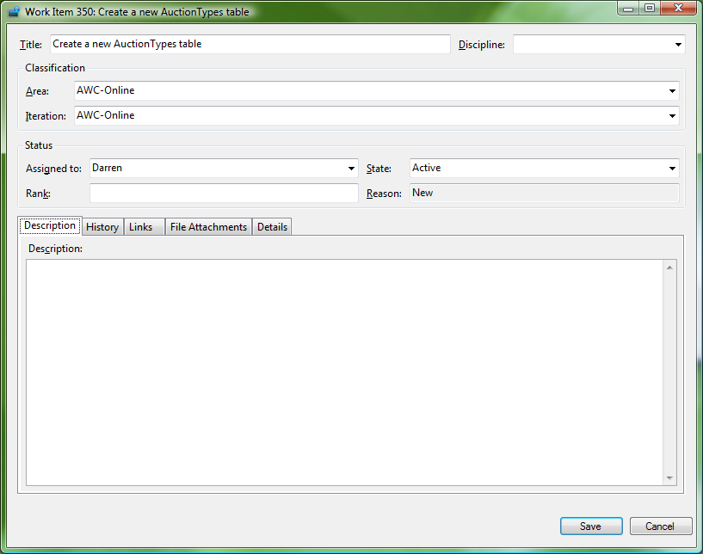

With some very simple configuration the estimates can be mapped to the TFS Work Item fields, per work item type, per project. This can be performed by one member of the team, most likely the one responsible for setting up the project, and then stored on the network share for all team members to reference.

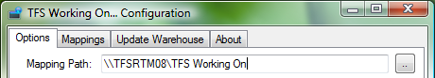

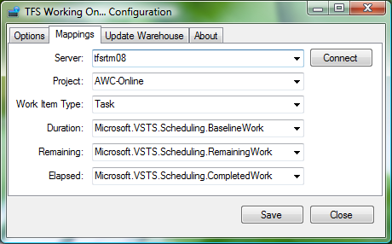

Features can be configured here also. Hovering over the help icon will give you details of the settings.

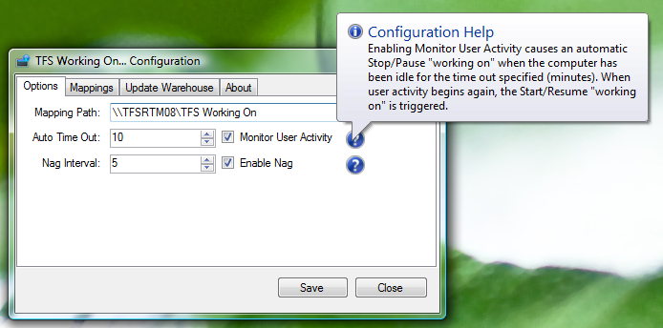

Auto Time Out will automatically stop working on when the computer is idle for the set time, and resume when activity begins again.

Nag will remind you when you are not working on anything.

